Interview: Jon Finkel Part 2
Toby Wachter
Friday, December 14, 2001
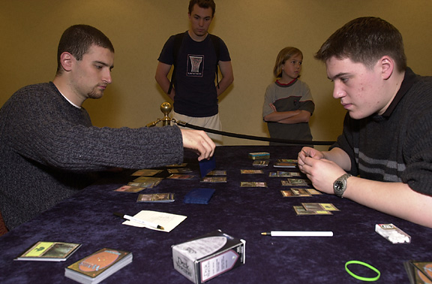
Best in the world: Finkel or Budde?
Sideboard: Have you ever considered yourself to be the best Magic player in the world?
Jon: I think I was definitely the best Magic player in the world for some period of time. Probably 1998 to 2000 would be fair to say without trying to sound arrogant or anything like that. I had the best results of that period. Results are obviously the bottom line, and right now Kai is doing much better than I am, so at this point I would say he has a very strong claim to be the best player in the world.
Sideboard: Do you have your own opinion on that? Let's put it this way... who do you think is the best Magic player in history?
Jon: That's a loaded question. It depends on how you determine best, you know? I could make a case for myself, just on the fact that I have the most lifetime winnings, which is the way I like to keep score. I'm sure other people disagree or have different opinions.
Sideboard: Well, Kai's behind by about $40,000 at this point.
Jon: Then he's a lot closer than he used to be. He hasn't played for as long as I have, so that does give him something in terms of being the best ever. I really don't know, in all honesty.

Sideboard: How does it feel to be classified as a Magic "poster boy"? You're mentioned in ads, and you were tapped for the Deckmaster set with Richard Garfield. Do you think there's any added pressure on you because of that? Even the average kid who just plays in his local card store and never goes to tournaments knows who Jon Finkel is. What does that mean to you?
Jon: There are times when it can be an issue, like when I'm at a tournament I feel like I have to be nice to people. I mean I like to be nice to people, but I'm not necessarily a social person, so I have to put in more effort. It's nice in some ways. I think most of the reason why I'm the poster boy, so to speak, is that my heyday was during the period when Magic was really exploding. I got very good at giving the answers that the Wizards people liked to hear (laughs). I said the right things about the game, and they were mostly true. I presented a relatively normal face to help debunk some of the stereotypes that Magic players often face. So is there any pressure? Yes, if I'm playing Magic I want to try to look nice and presentable, and act in a professional manner, but that's a good thing I think.
Sideboard: When did that change? At 1998 Pro Tour-New York you had the dyed hair, and at Worlds 2000 you had a shirt and tie. Did you consciously decide to make that change at some point?
Jon: It just kind of happened, it was a process. It happened probably somewhere around 1999, and I don't really know when I became Magic's poster boy. It was probably some time in late 1999 or 2000.
Sideboard: Do you feel that you have to set an example for kids because of who you are? For example, a while back Dave Price mentioned in an interview that he decided to stop smoking since it set a bad example for kids who play Magic.
Jon: Not really, I mean Dave's still smoking...
Sideboard: Really? (laughs)
Jon: Well I don't think that's the reason he stopped, I mean there's a lot of reasons to stop smoking. I try my best to be nice to people, and to be friendly and to try and help out. I'll talk to kids or play against them and stuff like that. I don't think my personal life is in the spotlight enough that I have to act a certain way to set an example, because most of the time I'm just a normal person and no one really cares what I'm doing.
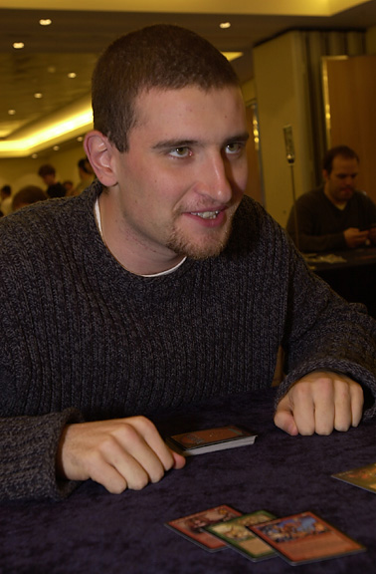
Sideboard: When you go to a Pro Tour, do you feel that you have to act differently than you normally would because you're around Magic players and a celebrity?
Jon: I find myself acting a little different, and I feel like there's attention on me more often, which can be annoying at times. I don't make a conscious effort to change how I act. It's a difficult question to answer, because it's hard to know exactly how you act the way you act. But I don't do that many things that I guess could be considered objectionable in a Magic tournament context anyway. I tend to be relatively polite, and no one has ever accused me of cheating or anything like that. If you do those two things, then that's all you really need to do to have a good reputation as a professional Magic player.
Sideboard: Does it feel strange to not be the poster boy anymore now that they're pushing Kai so much?
Jon: You know, for a while I thought it would feel odd. Being thought of as the best Magic player in the world was something that had been a part of me for a long time. Some people think Kai is the best, and he definitely is the best case out there right now. I found that it didn't bother me as much. It kind of surprised me.
Sideboard: Why do you think that is?
Jon: I really don't know. Just because he's good doesn't change how good I am or how well I'm going to do. If I'm good and he's better than I am, then that's fine. It's not like it's going to make me worse. I guess somewhere is the thought that if I practice I can become better, and maybe do better than he does.
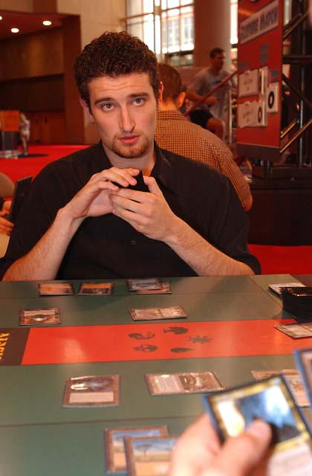
Sideboard: Are you saying that if you put in more effort you would do better, but you're choosing not to?
Jon: I don't know if I would do better or not, but it's something I think about. If I put in more effort I would definitely do better than I am now. I don't think I'd do ridiculously better, but preparation is obviously a strong part of the game. It's a very important part of the game, and it's a place where Kai has a definite advantage over me, and that's very relevant. I can say that if I put in effort I might do better than he would, but maybe I wouldn't. I really don't know, and the only way to find out is to put in that effort, and I don't know if I'm going to do that or not.
Sideboard: Is there any reason you don't want to put in the effort?
Jon: It's just like a time thing, you know? Again, you look inside and say "Do I want to play Magic right now?" and the answer is not "yes" often enough for me to get all that playtesting in.
Sideboard: So is it a matter of changing priorities?
Jon: I suppose. Like I said, I just don't find myself wanting to play Magic as much as I used to.
Sideboard: Do you feel like you still have something to prove at this point, or are you happy with what you've accomplished? Do you feel like you have to prove to the world that you're better than Kai, or at least on his level?
Jon: No, I don't really feel the need to prove anything to the world. I've done pretty well myself, and even last year I was still third or fourth or fifth on the annual money list, and I wasn't too far behind the top winner. It's nice to win and it's nice to make money, but I don't feel like I have to win for anyone else, or anything like that.
Sideboard: So you're saying it's more about the money than the glory? Not to put it so simplistically, but...
Jon: No, actually that's a really good way to put it. I had the glory for a long time and it kind of faded and became not that relevant to me.
Sideboard: Did the glory matter more than it does now?
Jon: There was a point where it was very important, but for the last year and a half at least it hasn't been as big of a deal.
Sideboard: How does it feel to have your own Magic card? 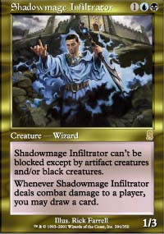
Jon: I really like having my own Magic card, it's actually one of the coolest things that's happened to me. It's a good card too, which is relevant. It's just really nice.
Sideboard: Do you think it's too good?
Jon: It might be. It's really, really good. I couldn't tell you at this point whether or not it's too good. I mean it's still a creature, so if it's too good, it's probably not a horrible thing for the game.
Sideboard: Was it a conscious effort to make it a good card? I remember back when Wrath of Leknif was first posted on the internet, a lot of people were saying things like "Jon Finkel is an egomaniac! He wants to make a card that everyone is going to use!" How do you feel about that?
Jon: I think anyone who is given the opportunity to make a card will try to make it as powerful as they can. That's my card and I'm going to be identified with it, and I don't want... I can't even think about (looks around on the table and sees a Moment's Peace) something like Moment's Peace to be my card. I want as good a card as they will let me make. Is that being egomaniacal? I don't really think so. I think anyone would act the same way. No one's going to be happy if they make a card that just sits in bins in the corner collecting dust.
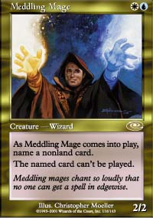
Longtime friend of the Shadowmage Infiltrator, Chris Pikula
Sideboard: Was it different because Kastle, Long and Pikula all had their cards before you did? Did you look at that and say to yourself "Oh wow, that's what I want"?
Jon: Yeah, winning the Invitational was definitely something I really wanted. The year before, I came inches away from beating Chris (Pikula) in the finals, and it was the one thing that I felt I really wanted to do. I had been World Champion, I had been Player of the Year, I had won a Pro Tour, I had won Nationals, but I hadn't won the Invitational. So, I really wanted a card. Part of the reason was that those other guys had their own cards, but part of it was just because it seemed really cool.
Sideboard: On a final note, what advice do you have for aspiring players?
Jon: There's no short and simple answer, because Magic is a complicated game. It's based around intuition and experience. The only thing I can say is play often, play against better players and try to challenge yourself. The biggest thing is to keep in mind during a game what's really important, and what isn't. Don't get hung up on things that don't really matter, and instead pay attention to the things in the game that are going to be pivotal. Of course, the question is "what is that?" and that's something you have to learn through experience.

